Rules and General Understandings

Regarding Behavior for
One Week Mission Teams*
(updated for the 2016 (missions season)
The following rules and understandings have developed over many years and experiences. Please learn them, respect them, and most importantly OBEY them. Your visit is a privilege that can be withdrawn by the staff, welfare department, or Mexican government at any time. Failure to respect these rules may result in being sent home early at your own expense.

Rules Concerning Your Team

You are living examples of your Lord and Savior. Act in a way that honors Him.
- You are a team. Help each other. Forgive each other. Love each other. Stick together.
- You are guests in a foreign country. Respect their customs and laws.
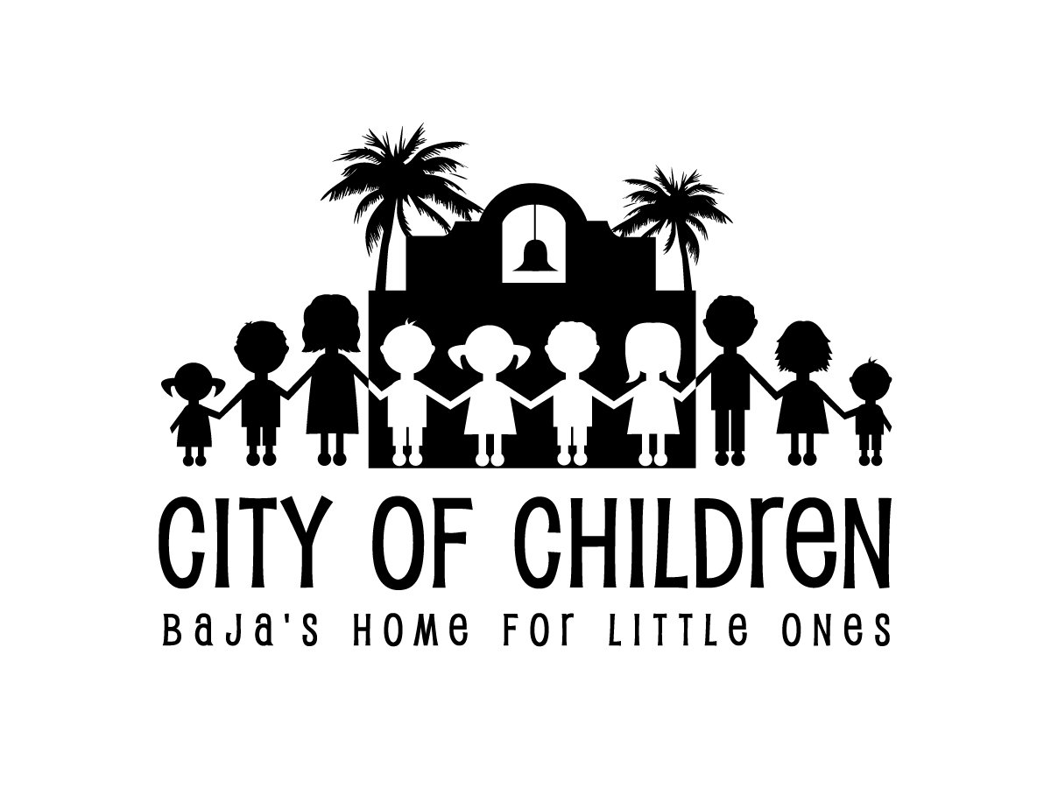
- The role of the team leader is to help maintain control and supervise the behavior of the team.
  - We expect the team leaders and adults to be responsible for the proper conduct of the team.
- For one week mission trips, trip participants must be in or entering the 9th grade or above to visit.
- All activities must be planned, organized, and coordinated with the office.
- We require lights out in all visitor dorms and kitchen by 10pm. Our kids go to bed early so please refrain from engaging in sports or noisy activities after 9pm.
- Do NOT leave the City of Children without the Director’s permission (especially if you are driving one of our vehicles)
- When visiting communities or churches outside the walls of the City of Children, you must return back to the home before dark. No one is allowed to leave the home after dark.
- Dress appropriately
  - Please do not wear short shorts, cut off shirts, tight clothing, bathing suits, oversized or excessively baggy clothing, body jewelry, camisoles, spaghetti strap shirts, or wild colored hair.
  - Please do not wear shorts in church on Sunday
  - Please do not wear leggings without shorts.
  - Shorts should be modest and no higher the 1 inch from the knee.
  - Please no sleeveless or low cut tops.
  - Boys no tank tops
  - Body Jewelry ( Piercing's) other than ear rings for girls must be removed. Tattoos must be covered at all times.
  - Shoes or sandals must be worn at all times.
  - Remember, the focus of your visit, it should not be on you.

- Do not bring or buy (while in town) drugs, alcohol, knives, guns, weapons of any kind, cigarettes or cigars, or fireworks when visiting the home.
- Beach trips and/or sun bathing are not allowed.
- While at the home, you are not allowed to use iPods or MP3 players, cell phones, video gaming devices, computers*, Blackberries, or any other form of personal electronic equipment.
* Team Leaders may bring a personal computer to use for communications home. Please use it only when it won’t be a distraction or temptation to the rest of your team and when there are no scheduled activities taking place.
- Electricity and water are expensive in Mexico. Please use them sparingly.
  - Keep the lights off when they are not in use. Take only one short shower per day. The Mexican sewer system requires that toilet paper and any other personal products to be put in the trash cans next to the toilet. If you flush it, you will clog the system, and you will clean it. You are responsible for emptying all of the bathroom trash cans during and at the end of your visit.
- Report any damage you have caused to our facilities to your team leader who in turn will report it to the Mexican Directors.
- Phone calls and/or e-mails home should be for emergency purposes only, subject to the approval of your team leader.
- If you have a special medical problem and/or condition, please consider your visit very carefully. Ensenada has adequate medical facilities for minor injuries such as broken bones or stitches. However, if you have a condition requiring more serious medical attention where time is of the essence, returning to the United States could prove to be more difficult and time consuming.

Rules Concerning Our Children
- During your visit, none of the children at the home are allowed to leave for any reason without the Director’s approval.
  - We encourage you to invite our children to eat with you but please plan ahead. Our children need permission from the Mexican Directors to do this. You are welcome to invite individuals, groups by dorm, or everyone.
- You are not allowed inside any of the children’s dorms.
  - The only exceptions to this rule is if you are being given an official tour by an employee of the home, or you are visiting the pre-school dorm during visiting hours (9:30-11:30am and 2-4pm). When visiting the pre-school dorm, you are only allowed in the living room, there must be at least two visitors present, and all teens and minors must be accompanied by an adult.
- This is not a trip for romance with our children or between yourselves.
  - Please refrain from public displays of affection (kissing, holding hands, etc.). Your role as a team member is to be the hands and feet of Jesus, both to each other and to our kids.
  - Please don’t get involved with our children except as friends. We are visited by the DIF (the Mexican Welfare Department from whom we receive our kids) on a monthly basis. They talk with our employees and our kids about your behavior. Our license to operate can be revoked by one bad act. Not only do we have to think about the kids we currently are taking care of, we have to think of the thousands of kids who will some day call the City of Children home. The DIF has added staff and increased their presence!
- After dark, please stay in the visitors areas.
  - Evening activities should begin no earlier than 6:30pm and must conclude for the mediano’s by 8pm and for the teens by 8:40pm. The tradition is for our visitors to provide a snack for everyone following the evening activities. When our kids go to bed, please do not follow them up to their dorm. For your own safety do not walk, jog, or run, around the perimeter wall. There are snakes and hazards that could be harmful.
- Please respect our dorm parents and their rules for our kids.
  - If a child is in trouble, do not talk to them, try and play with them, bring them food, distract them from their work, etc. Also, do not question the dorm parent as to why they are in trouble.

General Understanding for American Visitors
- Our teen visitor dorms are equipped with beds, mattresses, toilets, showers and sinks. You must provide your own towels, bathroom necessities, sleeping bags or bedding, and a pillow.
- We have two “American Hotels” for adults. Each room has either a double, single, bunk bed, or combination of the two. There is also a living room and partial kitchen in each Hotel. Bed linens and towels are furnished.
- Our weather is much cooler than everyone expects because of our close proximity to the Pacific Ocean and because we have no humidity. The following are average temperatures throughout the year in Ensenada:
  - Spring - Highs in the 70’s, Lows in the 40’s • Summer - Highs in the 90’s, Lows in the 60’s • Fall - Highs in the 80’s, Lows in the 50’S • Winter - Highs in the 70’s, Lows in the 40’s
- You are responsible for your food and preparation of all your meals. Our kitchen is fully equipped. We are proud of our kitchen facilities. Please assign a crew to clean them daily. This includes sweeping, mopping, and removing trash. Lunch times for our children are at 1pm and dinner is at 5:30pm.

*One week mission teams are defined as those groups who have applied and had their application approved to be a part of the annual spring or summer mission season at the City of Children. To read more about the rules and general understandings regarding weekend visits or other trips, please visit www.cityofchildren.com.

